Infosys Springboard Virtual Internship 6.0 Completion Report

Team Details:
Batch Number: 2
Start date: 04-SEP-2025
Name: K N Parthiv Rishi
Internship Duration: 8 Weeks

1. Project Title
Food Trends Understanding Customer Preferences in Food & Beverage(F&B)

2. Project Objective

The primary objective of this project, “Food Trends: Understanding Customer Preferences in Food & Beverage (F&B)”, is to analyze and interpret consumer food choices, nutritional patterns, and dietary behaviors using data visualization and business intelligence techniques. The project aims to uncover insights into how demographic and lifestyle factors — such as age, gender, height, weight, activity level, and dietary preferences — influence customers’ food selections and nutritional intake. By examining relationships between nutritional components (like protein, fat, fiber, sugar, sodium, and calories) and meal preferences (breakfast, lunch, snacks, and dinner), this project seeks to identify emerging food trends and their health implications across different customer segments.
A key goal of the project is to create a data-driven decision-support system through Power BI dashboards, enabling restaurants, food brands, and health organizations to better understand customer expectations and design personalized food recommendations. The integration of visual analytics provides an intuitive way to explore dietary patterns, price sensitivity, customer satisfaction (ratings), and disease associations — offering actionable insights that can enhance both business strategies and consumer well-being. The dashboards help stakeholders identify which diet types and food categories are most preferred, which nutritional elements correlate with higher ratings, and how pricing affects customer satisfaction.
Ultimately, the project aims to bridge the gap between consumer preferences and healthy eating by leveraging data analytics. Through interactive visualizations and key performance indicators (KPIs), it empowers decision-makers to forecast demand, tailor menus to specific customer groups, and promote balanced diets that align with modern lifestyle needs. This approach contributes to the evolving F&B industry by translating raw data into meaningful insights, fostering innovation, and enhancing customer-centric service delivery.

3. Project description
Overview:
- Food Trends: Understanding Customer Preferences in Food & Beverage (F&B) is a data-driven analytics project developed to analyze, visualize, and interpret food consumption behavior, dietary habits, and customer satisfaction within the food and beverage sector.
- The project leverages Power BI as a business intelligence and visualization platform to transform raw nutritional and demographic data into meaningful insights.
- It focuses on understanding how various factors — such as age, gender, dietary preference, activity level, calorie target, nutritional components (protein, fat, fiber, sugar, sodium, carbohydrates), and price — influence customer food choices, health goals, and satisfaction ratings.
- The system enables businesses, nutritionists, and food brands to identify emerging food trends, evaluate price–preference relationships, and promote personalized diet planning through interactive dashboard.

Technology Stack:
- Data Visualization Tool:
Power BI — used to create interactive dashboards, KPIs, slicers, and filters that visualize customer trends and nutritional insights.
- Data Storage and Management:
Microsoft Excel (.xlsx) — serves as the source data repository containing structured records of demographics, meal preferences, and nutrient information.
- Data Cleaning and Transformation:
Power Query (within Power BI) — used to preprocess and clean data by removing duplicates, handling missing values, and converting data into analytics-ready formats.
- Scripting & Data Modelling:
DAX (Data Analysis Expressions) — used to create calculated columns, measures, and dynamic aggregations for advanced analytical insights.
- Integration Tools:
Power BI Desktop — exclusively used for integrating datasets, modeling relationships, designing dashboards, and generating insights locally.

Functionalities:
This Power BI project provides a real-time, interactive platform to explore multi-dimensional insights across seven analytical dashboards:
- Demographic Insights Dashboard – Examines age, gender, and dietary segmentation to understand the population driving food preferences.
- Dietary Preferences and Averages Dashboard – Highlights nutrient averages and disease counts across diet types, genders, and calorie targets.
- Nutrients and Diseases Dashboard – Analyzes the relationship between nutrient intake, activity level, and disease occurrence using decomposition trees and Q&A visuals.
- Averages by Breakfast Suggestions Dashboard – Explores breakfast preferences, their nutrient averages, pricing, and rating trends to assess popular combinations.
- Lifestyle & Nutrition Impact Dashboard – Evaluates calorie balance, BMI, and activity level to understand how lifestyle affects nutrition and fitness goals.
- Nutrition and Health Insights Dashboard – Focuses on BMI, gender-based calorie status, and nutrient distribution to reveal key health indicators.
- Value & Cost Analysis Dashboard – Compares food cost with nutritional benefits and ratings, identifying the most cost-efficient nutrient sources and meal types.
Together, these dashboards form a comprehensive data visualization ecosystem that uncovers actionable insights into customer food behavior. The ultimate goal is to promote healthier eating habits, assist F&B industries in product strategy, and enable users to make informed dietary decisions backed by analytical evidence.

Security Features
- Data Privacy: Since all analysis was performed locally in Power BI Desktop, no cloud storage or online sharing was involved, ensuring complete data confidentiality.
- Access Control: Dashboards and datasets were saved in a secured local environment with restricted file access.
- Data Integrity: Source Excel files were protected from unauthorized edits, and only verified datasets were imported into Power BI.
Role-Level Control (Optional): Power BI supports Row-Level Security (RLS) for restricting data visibility if the report is later published or shared internally.

Deployment and Hosting
- Development Environment: Power BI Desktop was used exclusively for the creation, modeling, and visualization of dashboards.
- Data Source: The dataset was stored locally in Excel format and directly linked to Power BI for real-time refresh within the desktop environment.
- Deployment: No external hosting or cloud deployment was used; reports were exported as .pbix files and shared offline when needed.
- Scalability: The dashboards can be easily migrated to Power BI Service in the future for organization-wide access and scheduled data refresh.

Component | Technology / Tool | Purpose / Functionality
 | Microsoft Excel (.xlsx) | Stores raw demographic, dietary, and nutritional data
  Data Source
 | Power Query | Cleans, filters, and transforms raw data for analysis
  Data Cleaning
Data Modeling |  | Builds data relationships and calculated fields
  Power BI Desktop
Analytics Logic | DAX (Data Analysis Expressions) | Performs advanced calculations and KPI creation
Visualization | Power BI Dashboards | Displays insights through charts, cards, and interactive visuals
Security | Local File Protection, Restricted Access | Ensures data privacy and prevents unauthorized edits
Deployment | Power BI Desktop Environment
  Offline visualization and report sharing
Version Control | Local Backup & Iterative Saves | Maintains report versions and project progress

4. Timeline Overview

Week | Activities Planned | Activities Completed
Week 1 | Introduction to Power BI and its interface. Learned about different data visualization tools and how Power BI fits into Business Intelligence workflows. Imported sample datasets and explored basic chart types. | Completed the introduction to Power BI and understood its interface and components. Practiced connecting datasets, exploring chart types, and creating simple visualizations to understand data visualization basics.
Week 2 | Discussed project objectives and finalized the project title and dataset related to food trends and customer preferences. Understood the dataset structure and key columns such as age, gender, dietary preference, and nutritional components. | Finalized the project scope and dataset for the Food & Beverage domain. Explored all key columns and gained a clear understanding of how demographic and nutritional data can be used to identify food trends.
Week 3 |  | Used Power Query for data preprocessing and cleaning. Removed duplicates, handled missing records, and standardized column formats to ensure consistency and accuracy in the dataset.
  Focused on data cleaning and preprocessing using Power Query in Power BI. Removed duplicate entries, handled missing data, and standardized column names for smooth analysis.
Week 4 | Performed data modeling — created relationships among tables and calculated columns using DAX (Data Analysis Expressions). Developed basic measures like average calories, protein, and rating. | Built relationships among dataset tables and used DAX functions to create calculated columns and measures. Computed averages for calories, protein, fat, and ratings to support data-driven analysis.
Week 5 | Started designing dashboards. Created Demographic Insights and Nutritional Composition Analysis dashboards to visualize patterns by age, gender, and diet type. | Designed two dashboards — Demographic Insights and Nutritional Composition. Visualized age, gender, and diet-based data patterns and represented nutritional statistics using charts and cards.
Week 6 |  | Created dashboards on meal preferences, disease correlation, and pricing trends. Applied slicers and filters for interactivity and ensured dashboards clearly reflected user behavior and health insights.
  Designed additional dashboards focusing on Meal Preferences, Health & Disease Correlation, and Price vs Rating Analysis. Applied slicers, filters, and interactive visuals for better usability.
Week 7 | Developed final dashboards on Calorie Target vs Actual Intake and Dietary Recommendations. Added KPIs, cards, and decomposition tree visuals to improve analytical depth. | Completed dashboards on calorie comparison and dietary recommendations. Used KPIs and decomposition trees to enhance insights and refined dashboard layouts for better visualization.
Week 8 | Conducted final review and presentation of all 7 dashboards. Verified data accuracy, design consistency, and insights derived from visualizations. Prepared the final project report and presentation slides. | Finalized all dashboards and reviewed data accuracy and visual consistency. Conducted the project presentation and submitted the final documentation summarizing insights and findings

5a. Key Milestones

Milestone | Description | Date Achieved
Project Kickoff | The project began with understanding the problem statement — to analyze customer preferences, nutrition patterns, and pricing trends in the Food & Beverage (F&B) sector. The dataset was finalized, project objectives were defined, and tools such as Power BI Desktop, Excel, and Power Query were selected. | 15 - SEP - 2025
Prototype/First dashboard Draft | Designed the initial dashboards focusing on Demographic Insights and Nutritional Composition Analysis. Added basic visuals, slicers, and KPIs to test interactivity and data relationships. | 22 - SEP - 2025
Mid-Term Review |  | 06 - OCT - 2025
  Presented the partially completed dashboards showing Meal Preferences, Health & Disease Correlation, and Price vs Rating Analysis. Mentor feedback was received regarding visual clarity, KPI placement, and color consistency, which were implemented in subsequent iterations.
Final Submission | Submitted the complete Power BI project, including all seven dashboards, supporting documentation, and summary insights. Uploaded files and visual reports as part of the official internship evaluation process. | 28 - OCT - 2025
Presentation | Delivered a live demonstration showcasing the dashboard functionalities, insights derived, and business value generated. Discussed challenges faced, learnings gained, and possible future enhancements such as real-time data integration and cloud publishing. | 29 - OCT - 2025

5b. Project execution details

1. Data Collection & Import Module
Description:
This module involved collecting and importing the raw dataset containing demographic information, dietary preferences, nutritional details, and pricing data. The dataset served as the foundation for all analysis and visualization activities in Power BI.
Implementation:
- Source data was stored in Microsoft Excel (.xlsx) format.
- Imported into Power BI Desktop using the Get Data feature.
- Verified schema consistency and ensured all key columns (Age, Gender, Dietary Preference, Calories, Rating, Price, etc.) were properly recognized.
Purpose:
To establish a clean and structured foundation for analysis by preparing a consistent and accessible dataset for visualization.
2. Data Cleaning & Transformation Module
Description:
This stage ensured that the dataset was analytics-ready by removing inconsistencies, duplicates, and missing values using Power Query.
Implementation:
- Handled null or blank fields in dietary and nutrient columns.
- Normalized text formats (e.g., “Vegetarian” vs “veg”).
- Used Power Query Editor to perform column transformations and standardization.
- Created derived columns (e.g., BMI, Calorie-to-Protein Ratio) for deeper insights.
Purpose:
To enhance data accuracy and reliability before visualization, ensuring meaningful insights from the dashboards.
3. Data Modeling & Relationship Building Module
Description:
Focused on designing logical relationships between data tables and ensuring smooth filtering and cross-analysis among visuals.
Implementation:
- Established one-to-many relationships among key tables (Demographics, Nutrition, Meals).
- Applied DAX (Data Analysis Expressions) to define calculated measures (Average Calories, Total Protein Intake, Rating-to-Price Ratio, etc.).
- Enabled bidirectional filtering for interconnected visuals.
Purpose:
To create a robust data model that supports dynamic interactions and accurate analytical results.
4. Dashboard Design & Visualization Module
Description:
The central component of the project — responsible for designing multiple dashboards to visualize insights from the dataset.
Implementation:
- Created 7 interactive dashboards, including:
  - Demographic Insights Dashboard
  - Dietary Preferences and Averages Dashboard
  - Nutrients and Diseases Dashboard
  - Averages by Breakfast Suggestions Dashboard
  - Lifestyle & Nutrition Impact Dashboard
  - Nutrition and Health Insights Dashboard
  - Value & Cost Analysis Dashboard
- Used visual elements like bar charts, pie charts, donut charts, line graphs, KPI cards, slicers, and decomposition trees.
- Ensured colour uniformity, alignment, and professional formatting throughout.
Purpose:
To transform raw data into visually engaging insights that help understand customer preferences and nutritional behavior effectively.
5. Interaction & Filtering Module
Description:
This module enables dynamic exploration of data through slicers, filters, and Q&A features.
Implementation:
- Implemented slicers for attributes such as Age, Gender, Dietary Preference, and Activity Level.
- Added cross-filter interactions between visuals for multi-dimensional analysis.
- Configured Q&A Visuals to allow natural language queries (e.g., “Show average calories by diet type”).
Purpose:
To provide an interactive and user-driven analysis experience, allowing end-users to customize their data exploration.
6. DAX Calculation Module
Description:
This module involved the creation of advanced analytical measures using DAX to generate KPIs and custom metrics.
Implementation:
- Developed measures such as:
  - Average Calorie Target
  - Protein-to-Fat Ratio
  - Average Price by Rating
  - Sugar and Sodium Consumption Trends
- Used DAX time intelligence and aggregation functions for enhanced analytical precision.
Purpose:
To provide deeper quantitative insights and summarize key performance indicators across various dimensions.

7. Insights & Storytelling Module
Description:
Focused on extracting and presenting insights from the visualized data to highlight trends and patterns in customer preferences.
Implementation:
- Analyzed relationships between dietary type and calorie intake.
- Identified popular food items and their correlation with customer ratings.
- Highlighted health-conscious behavior among different demographic groups.
Purpose:
To convert analytical data into actionable business insights for understanding food and nutrition trends.
8. Testing & Validation Module
Description:
This module ensured data accuracy, proper dashboard navigation, and functional validation of all visuals.
Implementation:
- Verified DAX calculations using test data.
- Ensured filters and slicers updated visuals correctly.
- Conducted consistency checks across dashboards for proper alignment and responsiveness.
Purpose:
To guarantee that all dashboards deliver reliable, accurate, and error-free analytical results.

9. Documentation & Reporting Module
Description:
Captured all project-related activities, methodologies, visuals, and insights into a structured report format.
Implementation:
- Documented project objectives, methodologies, dashboards, and outcomes.
- Prepared PowerPoint and report documentation for final submission.
- Summarized insights derived from visualizations for academic evaluation.
Purpose:
To present the project in a clear, organized, and evaluative format for academic and professional review
10. Version Control & Collaboration Module
Description:
Used GitHub for project backup and collaboration within the team during dashboard design and testing.
Implementation:
- Managed dataset versions and Power BI (.pbix) files through GitHub repositories.
- Followed structured commit messages for tracking progress and revisions.
Purpose:
To maintain an organized workflow and ensure collaborative project development.

6. Snapshots / Screenshots
1. Demographic Insights Dashboard
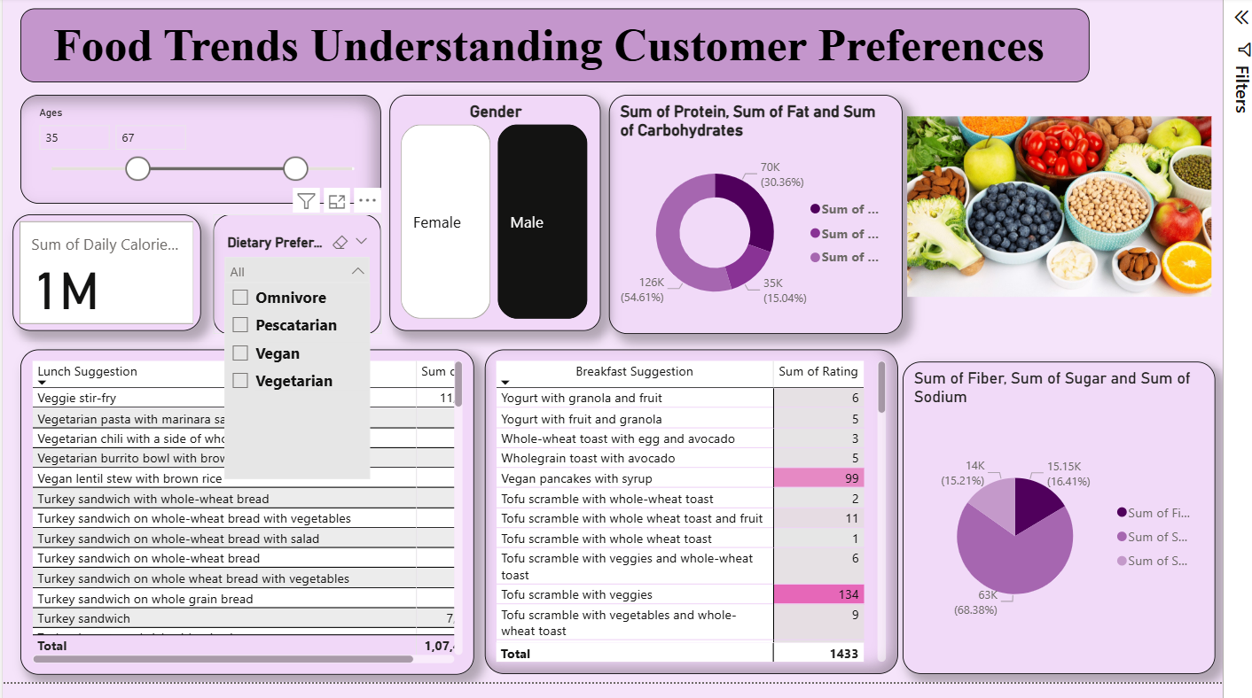

2. Dietary Preferences and Averages Dashboard
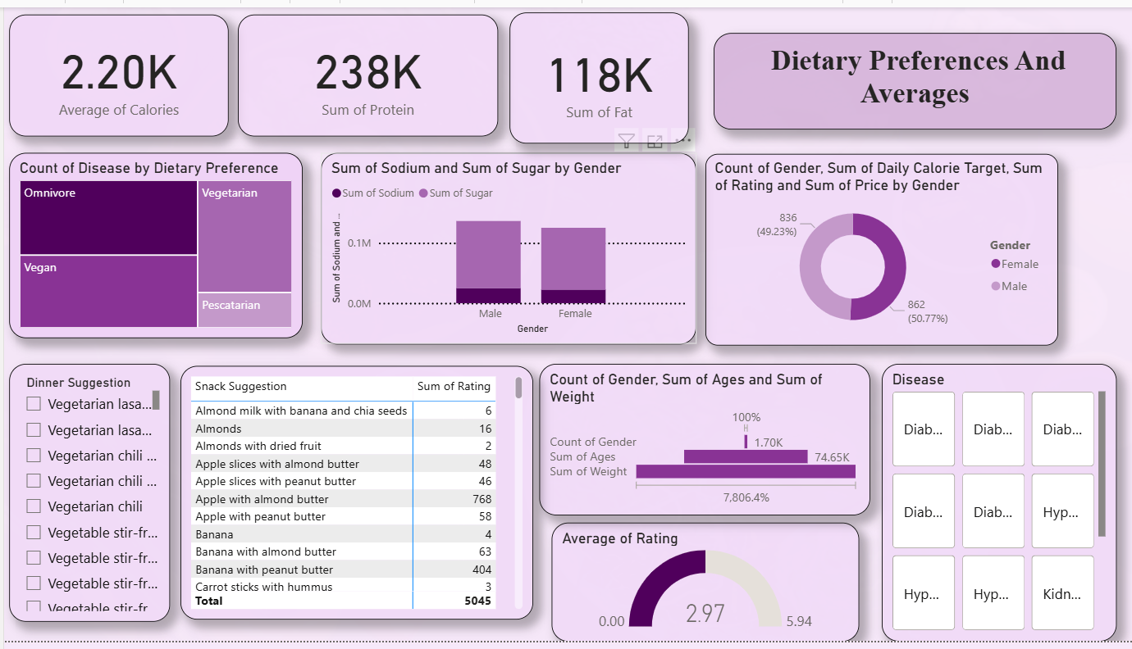

3. Nutrients and Diseases Dashboard

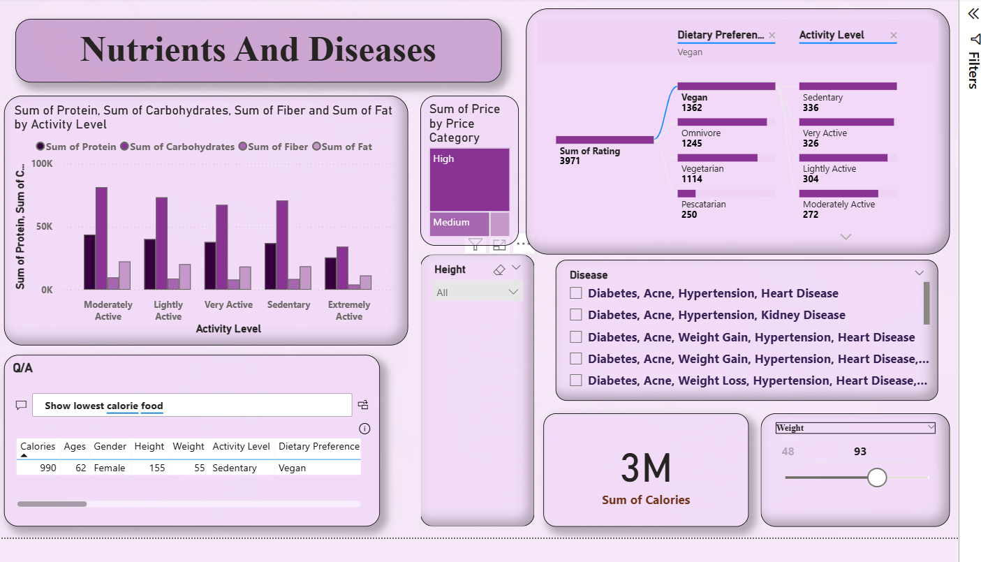

4. Averages by Breakfast Suggestions Dashboard
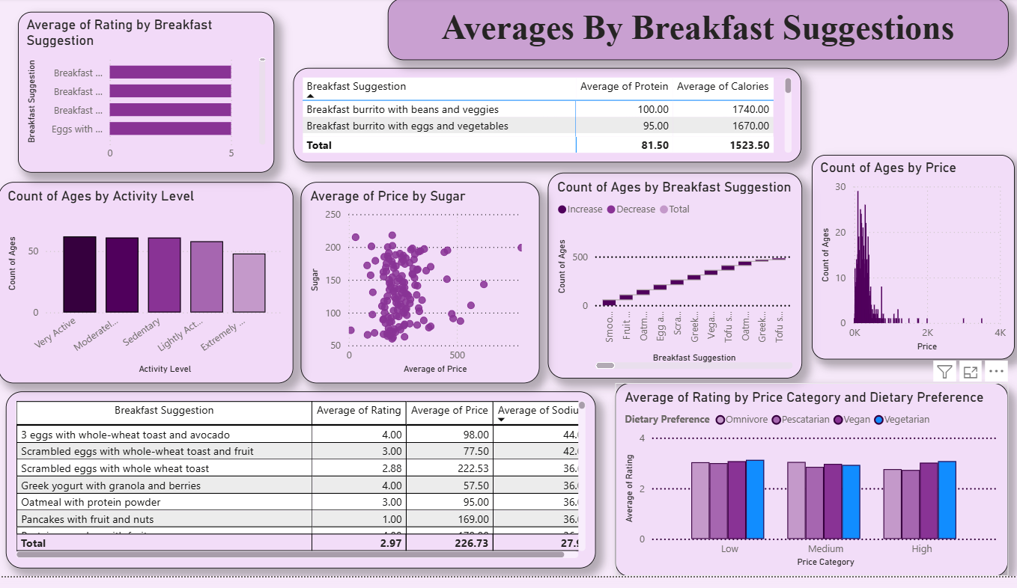

5. Lifestyle & Nutrition Impact Dashboard
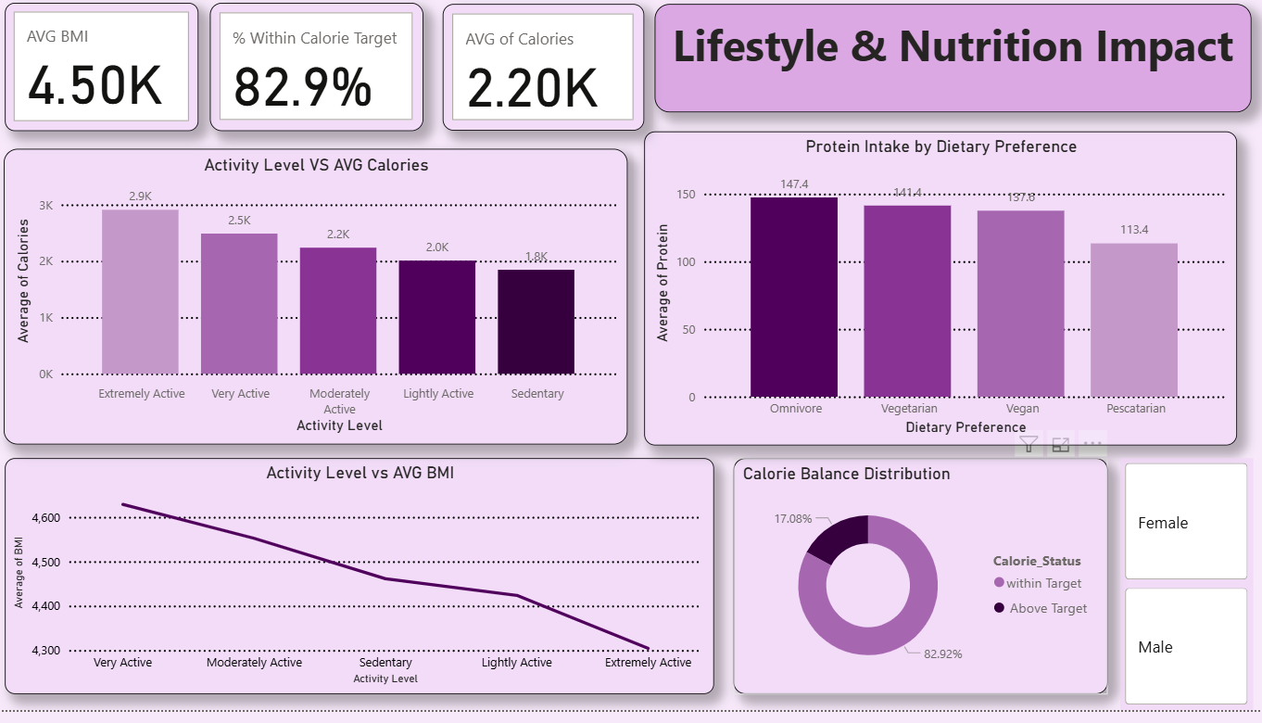
6. Nutrition and Health Insights Dashboard
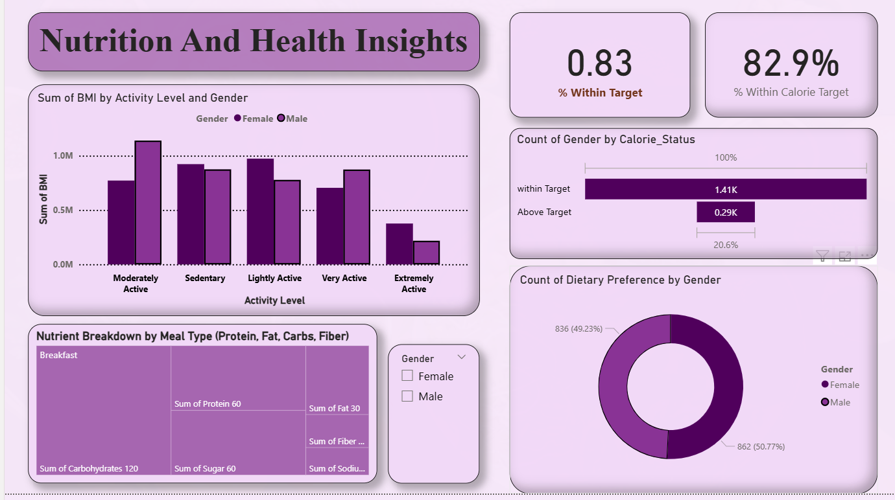

7. Value & Cost Analysis Dashboard
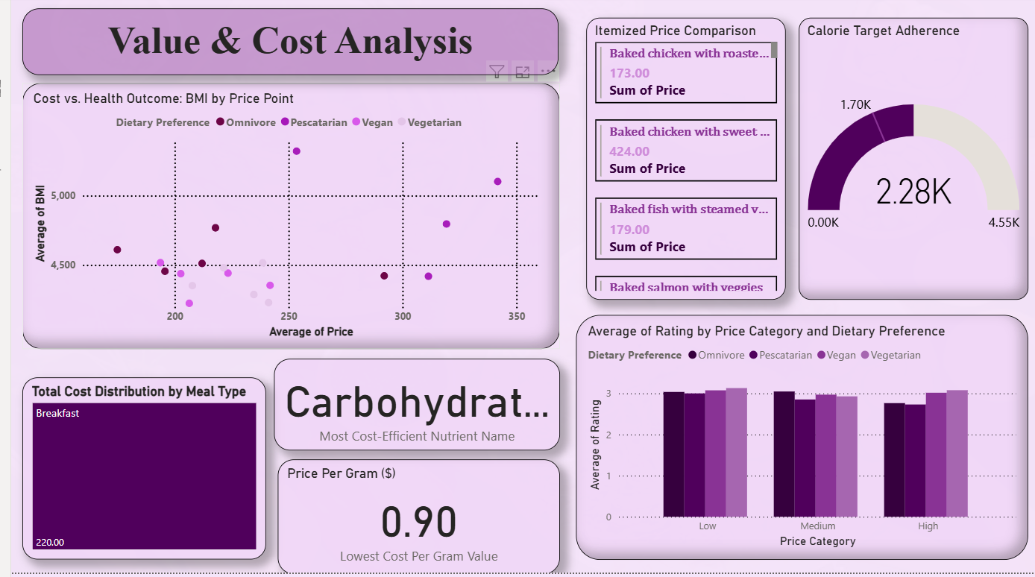

7. Challenges Faced

1. Data Source Integration
Description:
Integrating the Excel dataset with Power BI was initially challenging due to inconsistent data types, missing values, and column mismatches that caused errors during data import.
Resolution:
Used Power Query Editor to clean, format, and standardize data types. Verified relationships between tables and ensured proper schema alignment before loading into the model.
2. Data Quality and Cleaning
Description:
The dataset contained duplicate entries, blank cells, and non-standard text (e.g., “Veg”, “VEG”, “Vegetarian”), affecting accuracy of visuals.
Resolution:
Applied Power Query transformations to remove duplicates, replace nulls, and unify categorical values to ensure consistent and reliable data.
3. Data Modeling Relationships
Description:
Incorrect relationships between demographic and nutritional data caused circular dependency errors and inaccurate filtering.
Resolution:
Reconstructed one-to-many relationships, assigned appropriate keys, and optimized relationship directions to eliminate dependency loops.
4. Complex DAX Measures
Description:
Creating accurate DAX formulas for KPIs like average calorie target, nutrient ratios, and rating correlations required multiple iterations.
Resolution:
Simplified measures using variables (VAR) and modular DAX functions. Tested calculations step-by-step to ensure accurate results in all visuals.
5. Dashboard Performance Optimization
Description:
The dashboards initially loaded slowly due to multiple visuals and heavy measures.
Resolution:
Reduced visual count, optimized DAX calculations, and pre-aggregated data. Improved filter context handling for faster interactivity.
6. Design and Layout Consistency
Description:
Maintaining consistent themes, alignment, and visual hierarchy across seven dashboards was time-consuming.
Resolution:
Defined a standard design template with uniform color schemes, fonts, and layout. Applied the same design settings to all dashboards for a cohesive look.
7. Interpretation of Analytical Insights
Description:
Translating visual results into meaningful insights without misinterpretation required careful review and validation.
Resolution:
Rechecked calculated values and used clear titles, KPIs, and tooltips to enhance interpretability and storytelling in visuals.
8. Limited Collaboration Features
Description:
Using Power BI Desktop limited team collaboration and online sharing capabilities since Power BI Service wasn’t used.
Resolution:
Shared insights via PBIX and PDF exports and maintained updates through GitHub for version control and peer review.

8. Learnings & Skills Acquired

a. Technical Learnings
- Gained strong proficiency in Power BI Desktop for building interactive dashboards and visual reports.
- Learned data cleaning and transformation techniques using Power Query Editor to prepare structured datasets for analysis.
- Developed expertise in data modeling, creating relationships between multiple tables, and using Star Schema for efficient analytics.
- Acquired hands-on experience in writing DAX (Data Analysis Expressions) for calculating KPIs, ratios, and dynamic measures.
- Learned to design visually consistent dashboards using appropriate chart types, slicers, and formatting standards.
- Understood the use of filters, hierarchies, drill-throughs, and Q&A visuals to enhance interactivity and user experience.
- Used Excel and Power BI integration for real-time updates and improved data connectivity.
- Explored performance optimization methods like reducing visuals, aggregating data, and simplifying DAX queries for faster loading.

b. Soft Skills & Professional Growth
- Improved analytical thinking by deriving actionable insights from complex datasets.
- Strengthened attention to detail through data validation and dashboard refinement.
- Enhanced communication skills by presenting findings clearly through visuals and storytelling.
- Developed time management and task prioritization skills by balancing data preparation, visualization, and reporting stages.
- Learned collaboration and feedback adaptation, incorporating mentor suggestions to improve dashboard clarity and impact.

c. Overall Takeaway
This internship provided valuable exposure to the data analytics lifecycle—from raw data processing to meaningful visualization. It strengthened my technical and analytical skills in Power BI and built confidence in presenting data-driven insights effectively. Beyond tools and techniques, it also developed a deeper understanding of how data visualization supports business decision-making and enhances user engagement.

9. Testimonials from team

Testimonial – Tirumala

My experience working on the Demographic Insights Dashboard during the Infosys Springboard Virtual Internship 6.0 was both educational and rewarding. I gained hands-on experience in transforming raw data into meaningful visual insights using Power BI. Exploring features like slicers, filters, and drill-throughs enhanced my understanding of data storytelling and business intelligence. The guidance from mentors helped me refine my analytical skills and focus on accuracy and presentation. This project strengthened my confidence in handling end-to-end dashboard development independently.
Testimonial – Shivatharani

Working on the Dietary Preferences and Averages Dashboard was a great learning opportunity that helped me understand the importance of clear visualization in health and nutrition analytics. I learned how to analyze large datasets, apply DAX formulas for data aggregation, and create visually engaging charts. The internship allowed me to explore Power BI’s data modeling capabilities, and with continuous feedback from mentors, I improved my ability to interpret and present insights effectively.
Testimonial – Kshitija Karpe
Creating the Nutrients and Diseases Dashboard provided me with valuable exposure to how data can reveal relationships between nutrition patterns and health outcomes. I learned to clean and transform datasets using Power Query, build relationships across tables, and create calculated measures. The experience enhanced my analytical reasoning and helped me gain confidence in using Power BI for domain-specific analysis.
Testimonial – Parthiv Rishi
Developing the Averages by Breakfast Suggestions Dashboard taught me the importance of designing dashboards that are both informative and user-friendly. I explored Power BI visuals like cards, stacked bars, and slicers to present daily nutrient averages. The process improved my understanding of DAX, performance optimization, and layout design. Overall, this internship gave me practical exposure to professional dashboard creation and real-world data interpretation.
Testimonial – Maithili
While building the Lifestyle & Nutrition Impact Dashboard, I learned how to connect lifestyle factors such as activity level and dietary habits with nutritional intake. Power BI’s interactive features like drill-down and decomposition trees helped me uncover patterns easily. The internship encouraged me to approach data with curiosity, and I am grateful for the opportunity to strengthen both my technical and analytical thinking skills.
Testimonial – Anjali
The Nutrition and Health Insights Dashboard allowed me to dive deep into understanding correlations between nutrients and health indicators. I learned to use Power Query for data cleaning and DAX for advanced calculations. This experience helped me gain confidence in presenting analytical findings and understanding how data visualization can aid decision-making in the nutrition and health domain.

Testimonial – Anish Mane
Working on the Value & Cost Analysis Dashboard was a highly enriching experience. I learned to compare pricing trends, nutritional value, and consumer ratings effectively through Power BI visualizations. The internship gave me exposure to working with real-world datasets, handling complex calculations, and presenting data-driven insights clearly. This project has greatly enhanced my technical proficiency and analytical decision-making abilities.

10. Conclusion

The Power BI project “Food Trends: Understanding Customer Preferences in Food and Beverage” successfully transformed raw dietary and demographic data into meaningful insights through interactive dashboards. By analyzing variables such as age, gender, dietary preferences, nutrient intake, and pricing trends, the project provided a clear understanding of customer behavior and nutritional patterns.
Through visualization and analysis, key insights were drawn on how lifestyle, diet type, and health conditions influence food choices and overall nutrition balance. The dashboards enabled data-driven exploration, helping identify customer segments, popular dietary trends, and correlations between cost, nutrition, and satisfaction ratings.
Overall, this project enhanced analytical decision-making using Power BI’s visualization capabilities. It demonstrated how data analytics can empower businesses in the food and beverage sector to better align their offerings with evolving customer needs, ensuring both health-conscious and value-driven choices for consumers.

11. Acknowledgements

I would like to express my heartfelt gratitude to Infosys Springboard for providing me with the invaluable opportunity to be a part of the Springboard Internship 6.0 (Batch 2). This internship has been a truly enriching experience that allowed me to explore the power of data visualization and analytics using Power BI. It helped me gain practical exposure to interpreting real-world data, understanding customer behavior, and developing meaningful business insights through interactive dashboards.

I extend my sincere thanks to my mentor, Mrs. Nithyasri S. J, for her constant guidance, encouragement, and support throughout the course of this project. Her valuable feedback and mentorship helped me strengthen my analytical and technical skills while maintaining a clear focus on project objectives.

I am also deeply thankful to the Infosys Springboard Mentor Team for designing such a structured and impactful internship program. Their dedication and efforts provided an ideal platform to learn modern analytical tools and apply them effectively in real-world contexts.
Lastly, I would like to thank my teammates and peers for their cooperation, collaboration, and valuable contributions to the successful completion of this project. This internship has been a significant milestone in my learning journey, and the knowledge and experience gained here will continue to guide me in my future academic and professional pursuits.

